London Housing Project:

Problem Statement:
Which boroughs of London have seen the greatest increase in housing prices, on average, over the last two decades?

Data Source:

London Datastore : https://data.london.gov.uk/download/uk-house-price-index/70ac0766-8902-4eb5-aab5-01951aaed773/UK%20House%20price%20index.xls

Approach:

1. Prepwork:
Datasource has necessary information about the data of Housing Prices in each boroughs of London from 1995 to 2019, however, upon careful investigation, we found that there are some missing values and some extra information about the places that are not actually boroughs eg:

'Unnamed: 34' ,'Unnamed: 37', 'NORTH EAST', 'NORTH WEST', 'YORKS & THE HUMBER', 'EAST MIDLANDS', 'WEST MIDLANDS', 'EAST OF ENGLAND', 'LONDON', 'SOUTH EAST', 'SOUTH WEST', 'Unnamed: 47', 'England'

2. Cleaning the data

We removed these unwanted columns after carefully examining the data within them.

Shape of the original Dataset : (15405, 4)

Shape of the dataset with Not NULL values : (1442, 4)

Shape of the unique values in dataset with NULL: (1442 , 4)

We then dropped those values from the dataset since they didn’t contribute. We also take the average of the housing prices for each Year to gain proper insight of how the prices moved between 1995 and 2019

3. Visualizing the data:

We then now look at the dataset of one of the boroughs (Camden) and see, how the prices moved along the years.

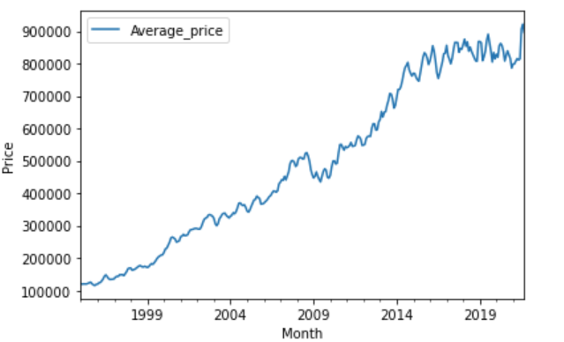
4. Modelling:

At this point, we have the valid list of London boroughs alog with their average prices per year. To answer our question, “ Which boroughs of London have seen the greatest increase in housing prices, on average, over the last two decades” we now need to get the ratio of the average prices of boroughs between 1998 and 2018. From the above visualization of Camden, we could see the prices went sharply between this period, although it dropped around 2009 but it recovered following year and continued its growth. So how did the other boroughs do?

Creating a Bar chart for all the boroughs and arranging them in descending order of the raitio, answers this query.

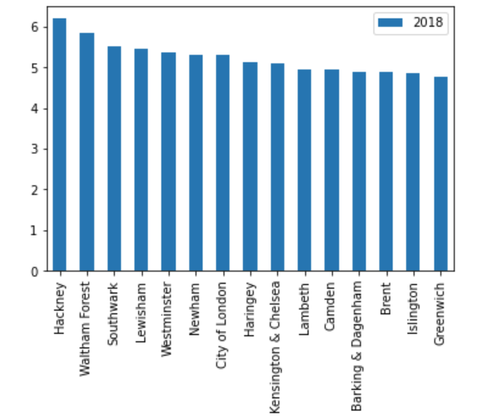
Conclusion:

Looking at the chart, it is clear that Hackney has seen the highest growth in the housing prices while Greenwich with the lowest. Carefully looking all the borough has seen gorwth of over 5 times their prices in 1998, there is marginal difference between each of them.

